Transactions Flow

(CashFlow Analysis, Daily Treasury Evolution and Daily Treasury Pivot)

* **Base Currency Transactions (Unreconciled past transaction)**
  1. Add Forecast Transaction in base currency from Forecast Transaction Editor (ex: amount 120 USD dated 28-Jul) and keep transaction unreconciled.

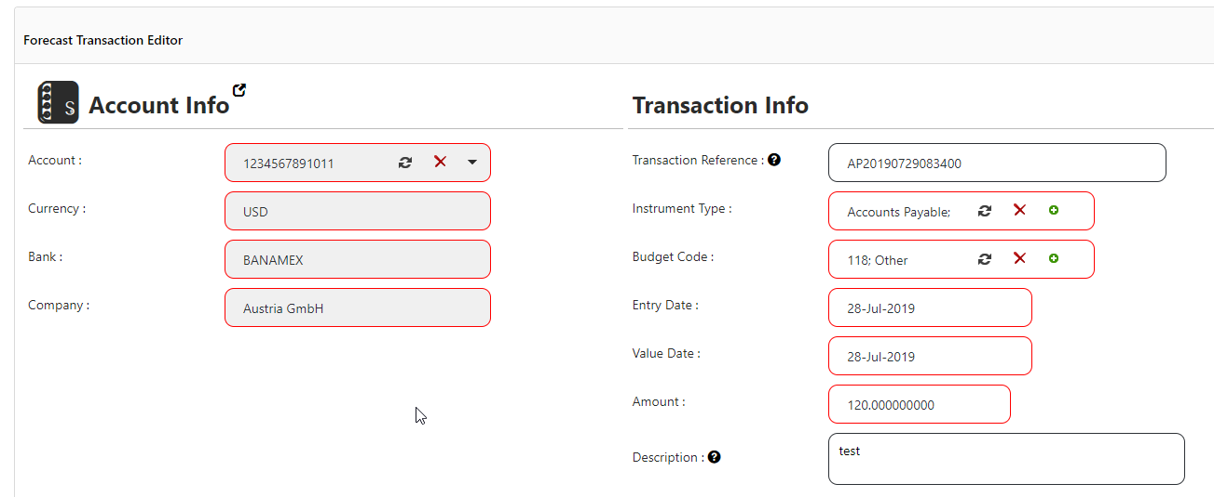

* 1. Go to CashFlow Analysis and generate report for dates 28 Jul till 30 Jul. The transaction will be categorized as **F (Forecast).**

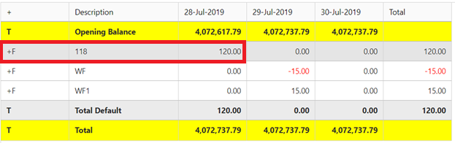

* 1. Go to Daily Treasury Evolution generate report for dates 28 Jul till 30 Jul. The transaction will **NOT** be displayed in the report since it is a past transaction and it is still unreconciled (Not actual yet)

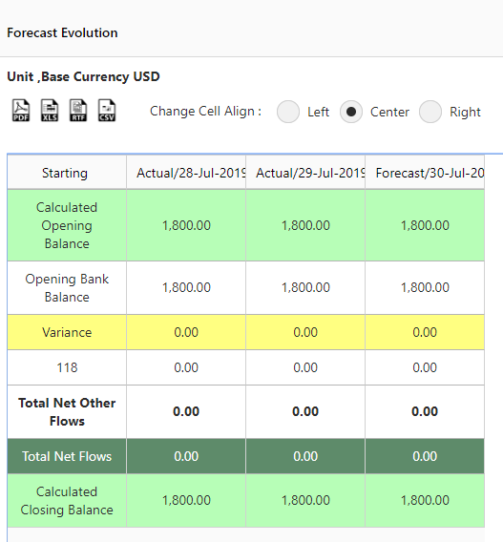

* 1. Go to Daily Treasury Pivot generate report for dates 28 Jul till 30 Jul. The transaction will be displayed in the report as **Forecast Balance**

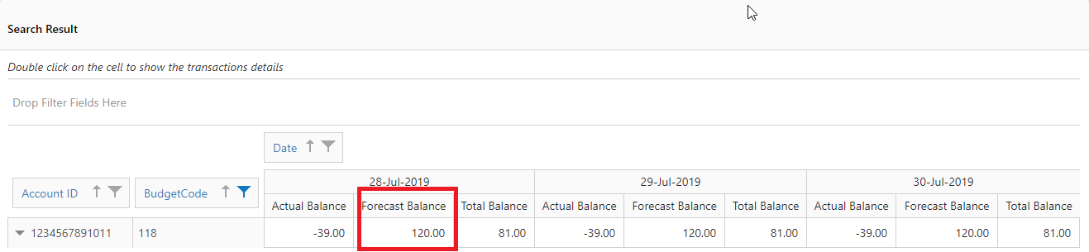

* **Base Currency Transactions (Reconciled past transaction)**
  1. Add Forecast Transaction in base currency from Forecast Transaction Editor (ex: amount 120 USD dated 28-Jul) and reconcile the transaction.
  2. Go to CashFlow Analysis and generate report for dates 28 Jul till 30 Jul. The transaction will be categorized as **A (Actual).**

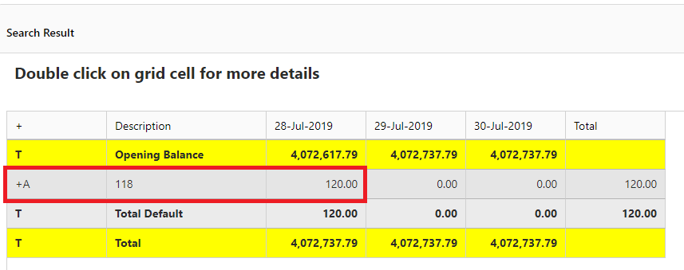

* 1. Go to Daily Treasury Evolution generate report for dates 28 Jul till 30 Jul. The transaction will be displayed in the report since it is a past actual transaction

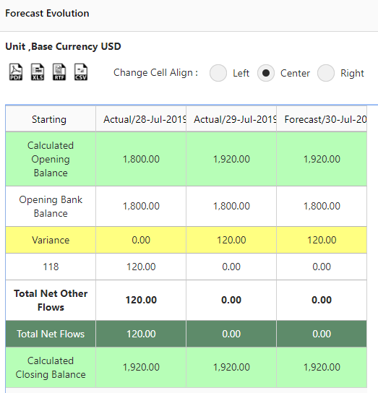

* 1. Go to Daily Treasury Pivot generate report for dates 28 Jul till 30 Jul. The transaction will be displayed in the report as **Actual Balance** (summing actual transactions per budget code).

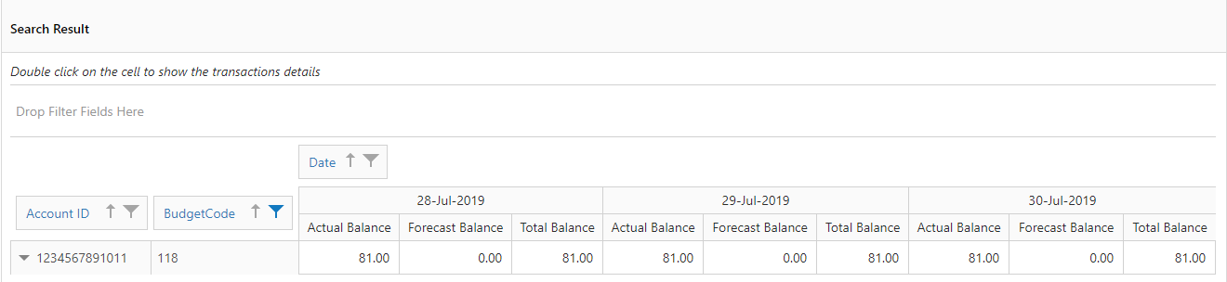

* **Base Currency Transactions (Unreconciled future transaction)**

1. Add Forecast Transaction in base currency from Forecast Transaction Editor (ex: amount 240 USD dated in the future) and keep transaction unreconciled.

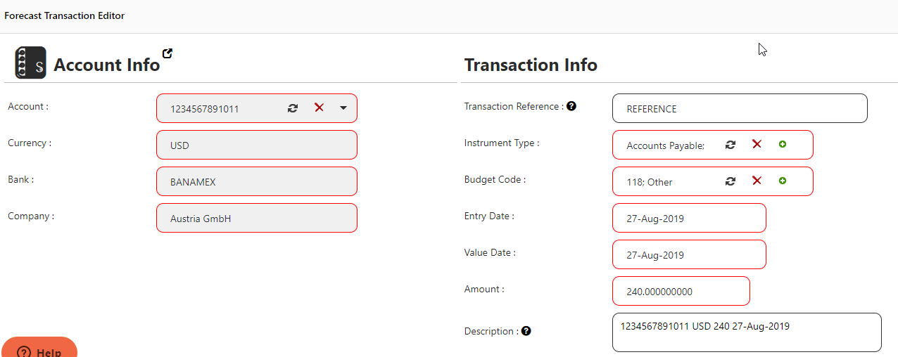

1. Go to CashFlow Analysis and generate report for dates 26 Aug till 30 Aug. The transaction will be categorized as **F (Forecast).**

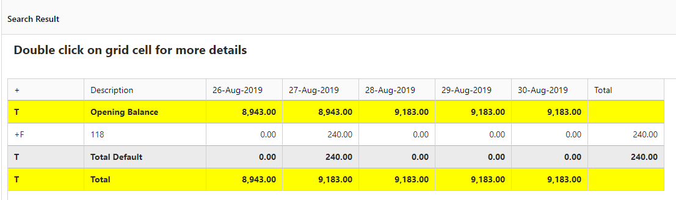

1. Go to Daily Treasury Evolution generate report for dates 26 Aug till 30 Aug. The transaction will be displayed in the report since it is a future transaction although it is still unreconciled (Not actual yet)

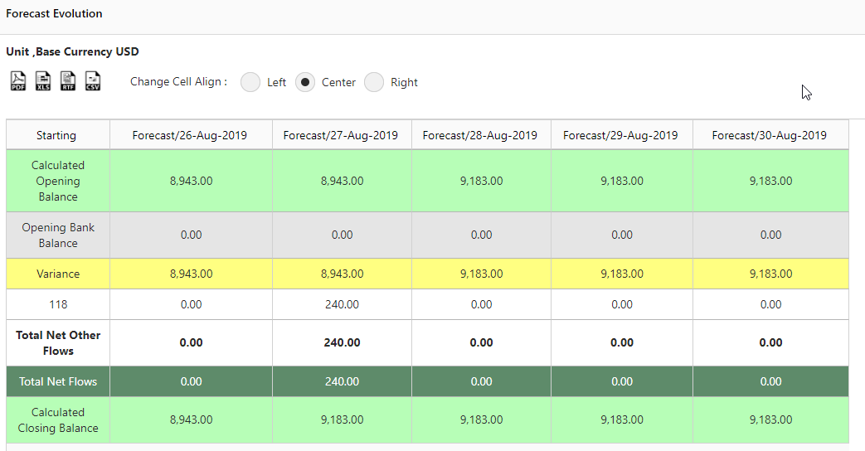

1. Go to Daily Treasury Pivot generate report for dates 26 Aug till 30 Aug. The transaction will be displayed in the report as **Forecast Balance**

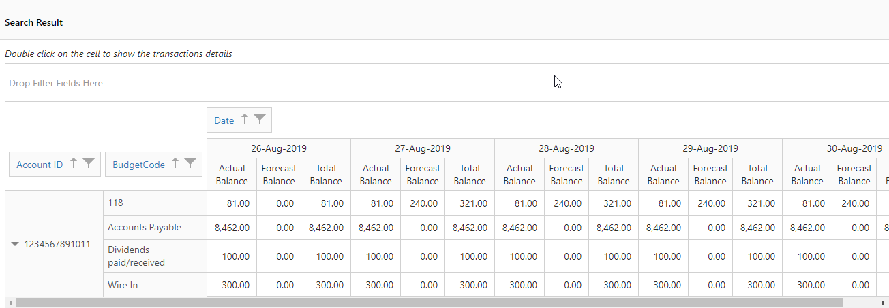

* **Base Currency Transactions (Reconciled future transaction)**
  1. Add Forecast Transaction in base currency from Forecast Transaction Editor (ex: amount 120 USD dated 28-Aug) and reconcile the transaction.
  2. Go to CashFlow Analysis and generate report for dates 26 Aug till 30 Aug. The transaction will be categorized as **A (Actual).**

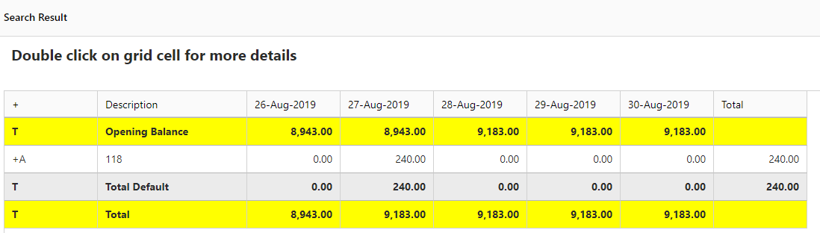

* 1. Go to Daily Treasury Evolution generate report for dates 26 Aug till 30 Aug. The transaction will **NOT** be displayed in the report since it is a future actual transaction

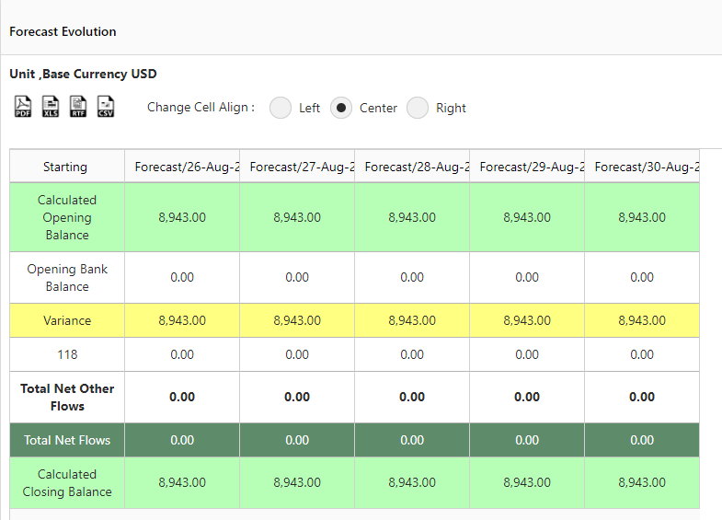

* 1. Go to Daily Treasury Pivot generate report for dates 26 Aug till 30 Aug. The transaction will be displayed in the report as **Actual Balance** (summing actual transactions per budget code).

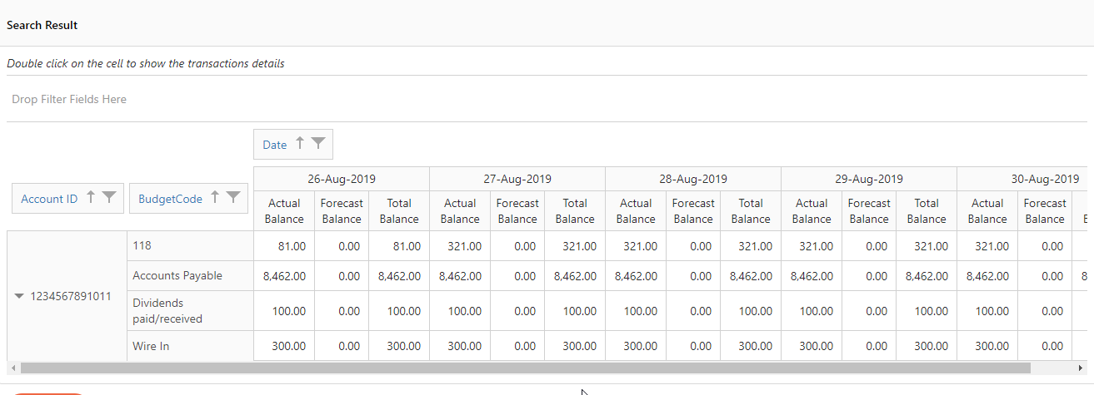

* **Non-Base Currency Transactions (Cash Flow Analysis)** 
  1. Add Forecast Transaction in non-base currency from Forecast Transaction Editor (Ex: 100 EUR having the below FX rates to USD). Keep transaction unreconciled.

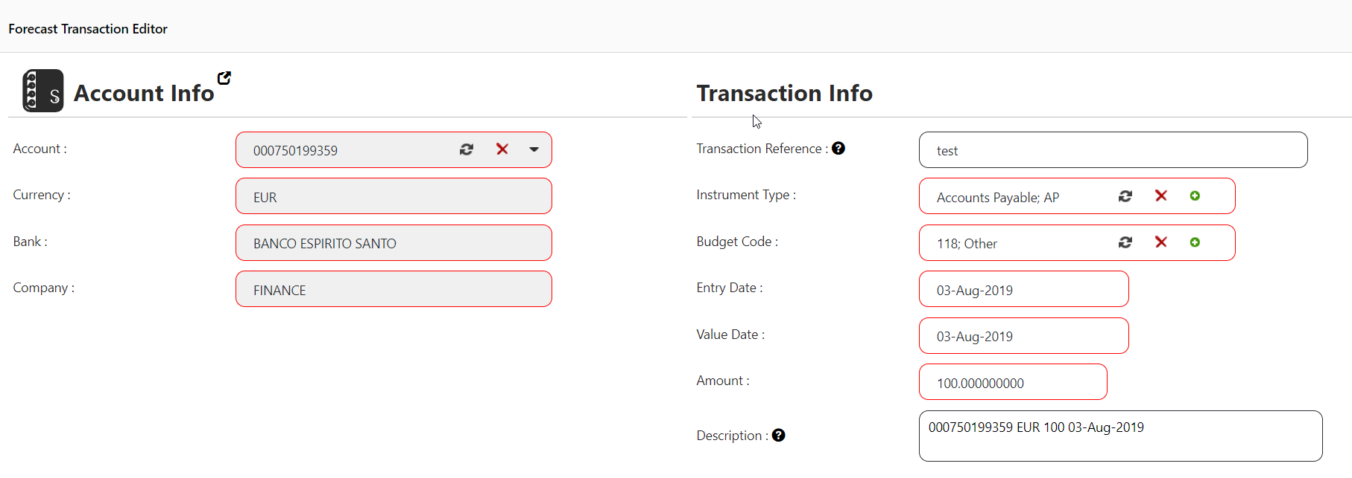

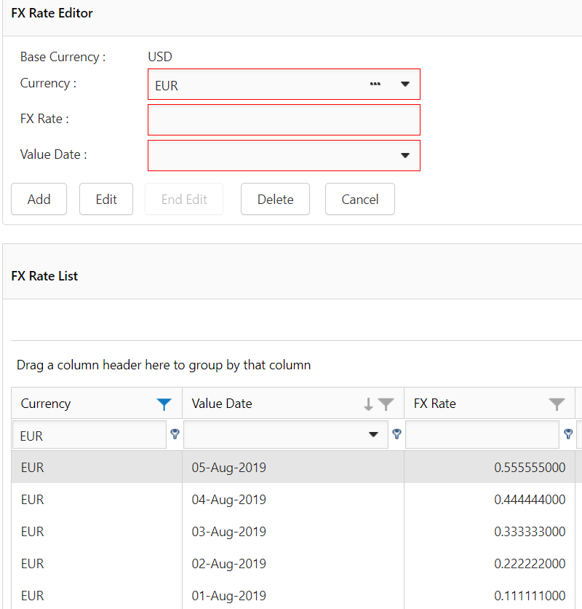

* 1. Go to CashFlow Analysis and generate report for dates 01 Aug till 05 Aug without selecting the option “Calculate the Forecast Based on Daily Rate”. The transaction will be categorized as **F (Forecast).** Transaction rate used is the latest rate (**in this case 0.555555**) generating a forecast with amount 180.02 on 3-Aug

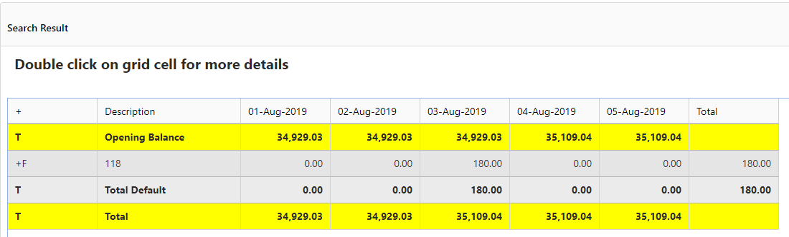

* 1. Go again to CashFlow Analysis and generate report for dates 01 Aug till 05 Aug and select the option “Calculate the Forecast Based on Daily Rate”. The transaction will be categorized as **F (Forecast).** Transaction rate used is the daily rate (**in this case 0.333333**) generating a forecast with amount 300.03 on 3-Aug

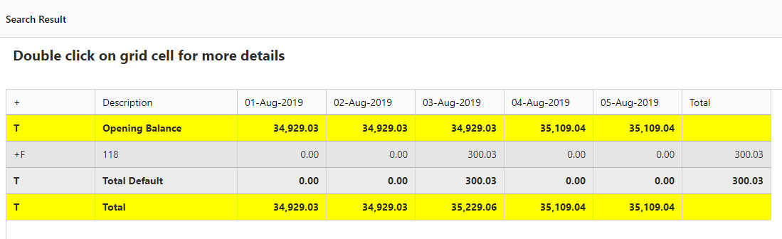

* 1. Reconcile the transaction and go again to CashFlow Analysis and generate report for dates 01 Aug till 05 Aug without selecting the option “Calculate the Forecast Based on Daily Rate”. The transaction will be categorized as **A (Actual).** Transaction rate used is the latest rate (**in this case 0.555555**) generating a forecast with amount 180.02 on 3-Aug

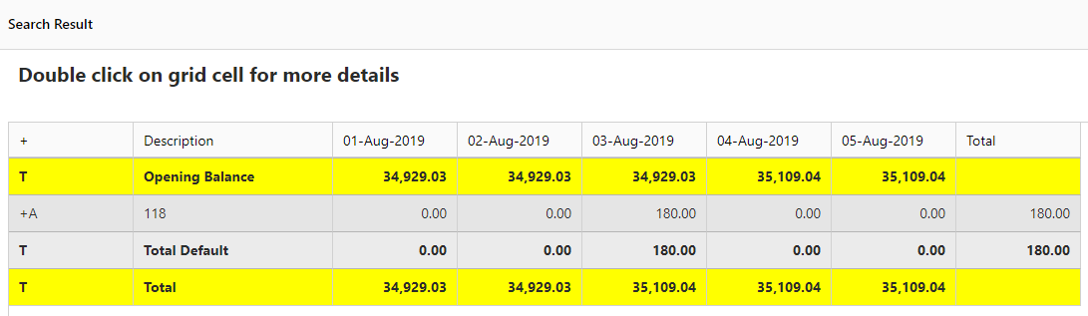

* 1. Reconcile the transaction and go again to CashFlow Analysis and generate report for dates 01 Aug till 05 Aug and select the option “Calculate the Forecast Based on Daily Rate”. The transaction will be categorized as **A (Actual).** Transaction rate used is the daily rate (**in this case 0.333333**) generating a forecast with amount 300.03 on 3-Aug

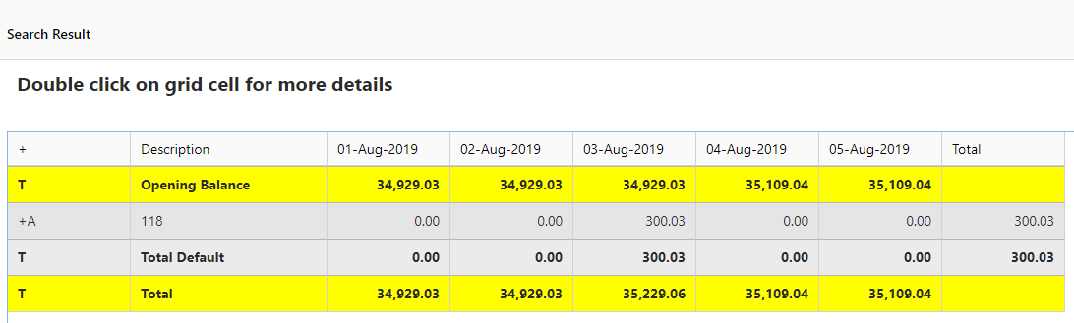

* **Non-Base Currency Transactions (Daily Treasury Evolution)** 
  1. Add Forecast Transaction in non-base currency from Forecast Transaction Editor (Ex: 100 EUR having the below FX rates to USD). Keep transaction unreconciled.





* 1. Go to Daily Treasury Evolution and generate report for dates 01 Aug till 05 Aug without selecting the option “Calculate the Forecast Based on Daily Rate”. The transaction will NOT be displayed since this is a past forecast transaction. Only past actual transactions will be displayed in the report.
  2. Go to Daily Treasury Evolution and generate report for dates 01 Aug till 05 Aug and select the option “Calculate the Forecast Based on Daily Rate”. The transaction will NOT be displayed since this is a past forecast transaction. Only past actual transactions will be displayed in the report.

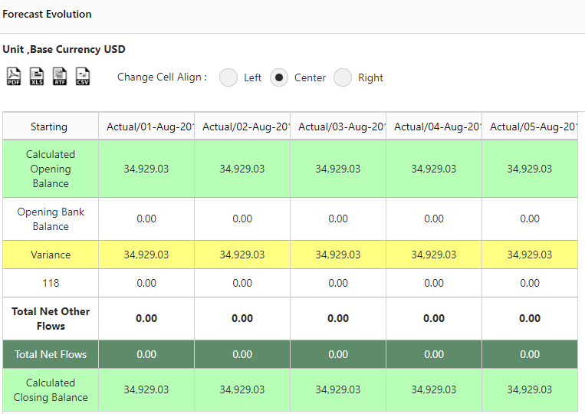

* 1. Go to Daily Treasury Evolution and generate report for dates 01 Aug till 05 Aug but do not select the option “Calculate the Forecast Based on Daily Rate”. The transaction will be displayed since this is a past actual transaction. Only past actual transactions will be displayed in the report. Transaction rate used is the latest rate (**in this case 0.555555**) generating a forecast with amount 180.02 on 3-Aug

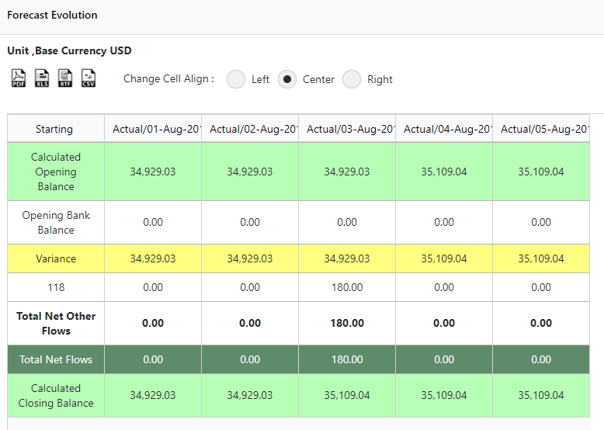

* 1. Go to Daily Treasury Evolution and generate report for dates 01 Aug till 05 Aug and select the option “Calculate the Forecast Based on Daily Rate”. The transaction will be displayed since this is a past actual transaction. Only past actual transactions will be displayed in the report. Transaction rate used is the latest rate (**in this case 0.333333**) generating a forecast with amount 300.03 on 3-Aug

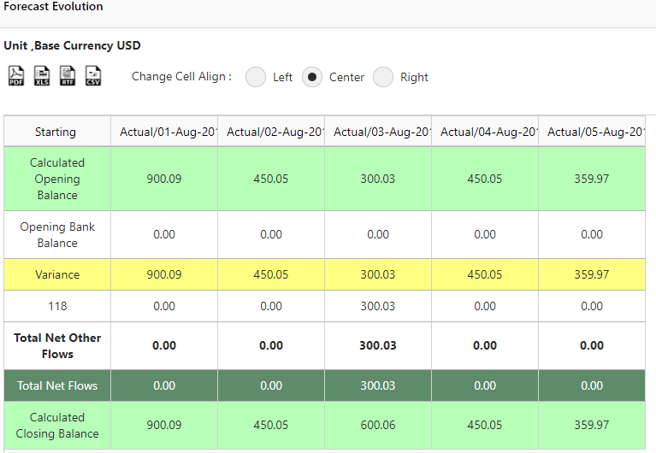

* **Non-Base Currency Transactions (Daily Treasury Pivot)** 
  1. Add Forecast Transaction in non-base currency from Forecast Transaction Editor (Ex: 100 EUR having the below FX rates to USD). Keep transaction unreconciled.





* 1. Do not reconcile and go to Daily Treasury Pivot and generate report for dates 01 Aug till 05 Aug. Transaction rate used is the latest rate (**in this case 0.333333**) generating a forecast with amount 300.03 on 3-Aug.

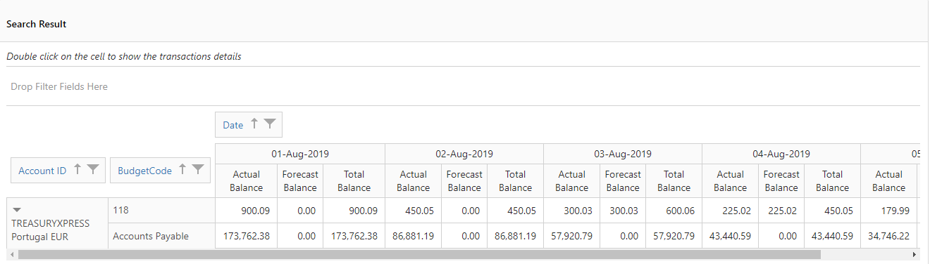

* 1. Reconcile the transaction then go to Daily Treasury Pivot and generate report for dates 01 Aug till 05 Aug. Transaction rate used is the latest rate (**in this case 0.333333**) generating an actual having amount 300.03 on 3-Aug.

